 | Advances in Optics and Computer Vision  Journal homepage: http://www.aocv.ir | AOCV

Article Title

First Author
Corresponding Author*

First affiliation, Name, City, Country, Iran
*Corresponding Author, Email: …….

ARTICLE INFO |  | ABSTRACT
Article history:  - Received 00 December 00  - Received in revised form 00 January 00  - Accepted 00 February 00 |  | Font << Times New Roman (Headings CS) (10)- italic
Keywords:
Each keyword to start on a new line

 |  | © 2017 xxxxxxxx, all rights reserved.

- Main titles
Here introduce the paper, and put a nome¬nclature if necessary, in a box with the same font size as the rest of the paper. The paragraphs continue from here and are only separated by headings, subheadings, images and formulae. The section headings are arranged by numbers, bold and 10 pt. Here follows further instructions for authors.

1-1. Subtitles: Times New Roman 10 bold and left aligned
- The references should not be introduced in the middle of paper, just should be numbered in bracket and at the end of full paper mentioned.[1]
- Introduction of parameters and variables: Every parameter or variable must be introduced immediately after its first appearance in the text.

1-2. Formulas and equations
The formulas or equations must be left aligned. All the formulae or equations must be "Times New Roman 11" and numbered from 1. The number of each equation or formulae must be inside parentheses and located in the right of the formulae as following:

(1) | Sin 2θ= 2sinθ cosθ
(2) | (a+b) 2=a2+b2+2ab

1-3. Tables
Each table must be specified by a title and a number from 1 which shall be mentioned above the table, center aligned, in Times New Roman 8 bold. The tables shall be presented inside the text immediately after their first reference.(table1)

Table 1 - Example of a legible table
First | Second
Third | Fourth
Fifth | Sixth

All the texts inside the tables shall be Times New Roman 8

1-4. Figures and charts
Each figure and chart must be specified with a title and number from 1 which shall be mentioned below the figure or chart, center aligned, in Times New Roman 11 bold. The figures must be presented inside the text immediately after their first reference.(Fig. 1) The unit in figures is
necessary. All the numbers, quantities, texts and legends inside the figures shall be Times New Roman 8. Each figure or chart shall be separated by one blank line (Times New Roman 10) from the previous and subsequent texts.

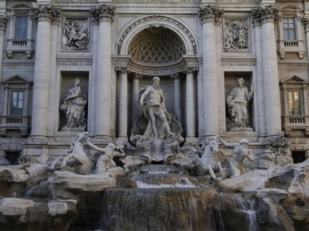
4. Conclusion
It is necessary for full paper to include the conclusion section after the main text. Following you can add acknowledgement section, if needed.
Reference
References must be mentioned at the end of the text according to their order in the main text. References must be in Times New Roman (8).
- C. Harris, M. Stephens, "A combined corner and edge detector," 4th Alvey Vision Conference, p. 147–151, 1988.
- J. Ben-Arie, Z. Wang, "Pictorial recognition of objects employing affine invariance in the frequency domain," Pattern Analysis and Machine Intelligence, vol. 20, p. 604–618, 1998.
Figure 1- sample

